ASSIGNMENT-2

AI Assisted Coding
Name :- Gaddam srinidhi
HTNO :- 2303A52285

Task 1:
Prompt:
#Book Class Generation
Generate a Python class Book with attributes title, author, and a summary () method.
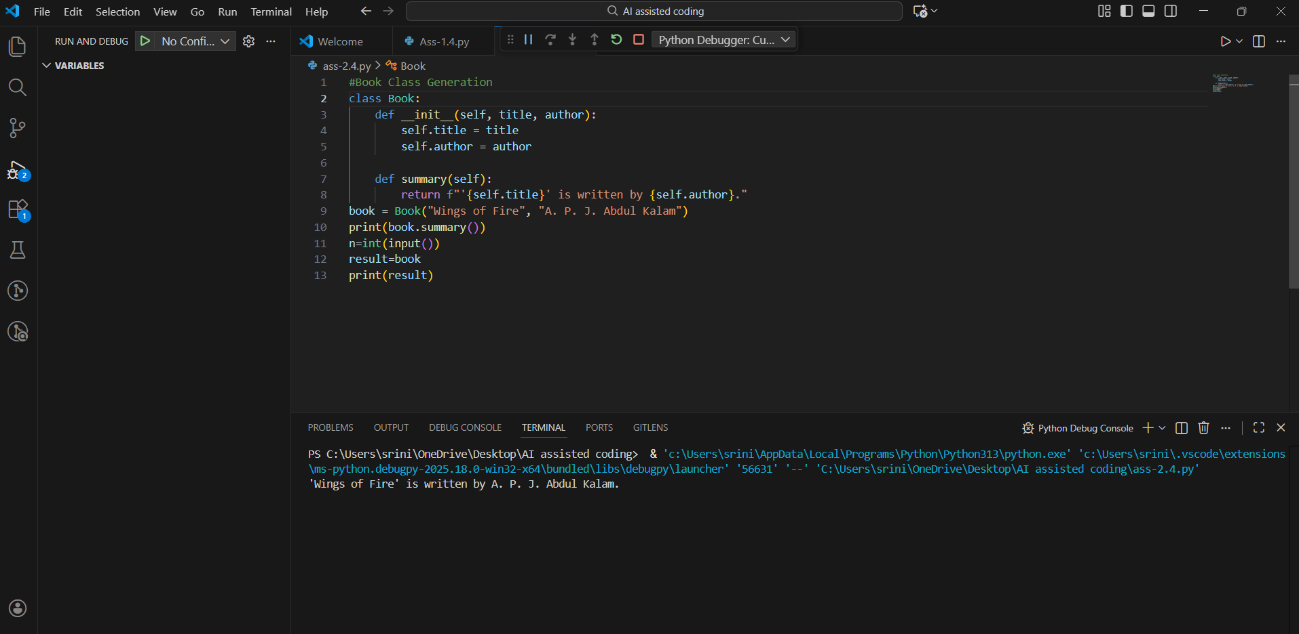
Observation:
- The generated Book class follows proper object-oriented programming principles.
- The constructor (__init__) is correctly used to initialize the title and author attributes.
- The summary() method provides a meaningful and readable description of the book object.
- Thecodeissimple,clean,andeasytounderstand,makingitsuitableforbeginners.
- Use of formatted strings(f-strings) improves out put clarity and readability.
- The class design supports reusability and scalability in a library management system.
- The code lacks input validation, which could be improved for real-world applications.

Task 2:
#Sorting Dictionaries with AI
Prompt:
Generate Python code to sort a list of dictionaries by age.
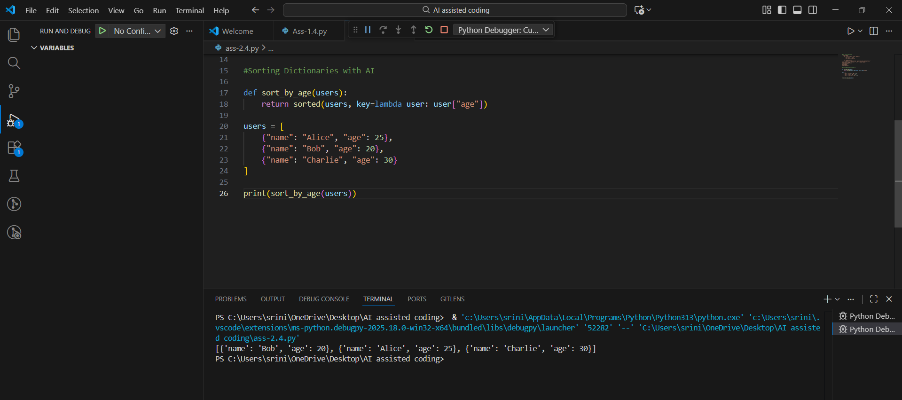
Observation:
- Both Gemini AI and Cursor AI correctly use Python’s built-in sorted() function.
- Sorting is performed using a lambda function as the key, ensuring concise logic.
- The time complexity for both implementations is O(n log n), which is efficient.
- Gemini AI’s solution is shorter and suitable for quick scripting tasks.
- Cursor AI’s solution improves code clarity and reusability by using a function.
- Cursor AI output is more maintainable for large or scalable applications.
- Both approaches preserve the original data structure while returning sorted results.
- Overall performance is similar, but Cursor AI provides better readability and structure.

Task 3: Calculator Using Functions
Prompt:
Generate a basic calculator using functions and explain how it works.
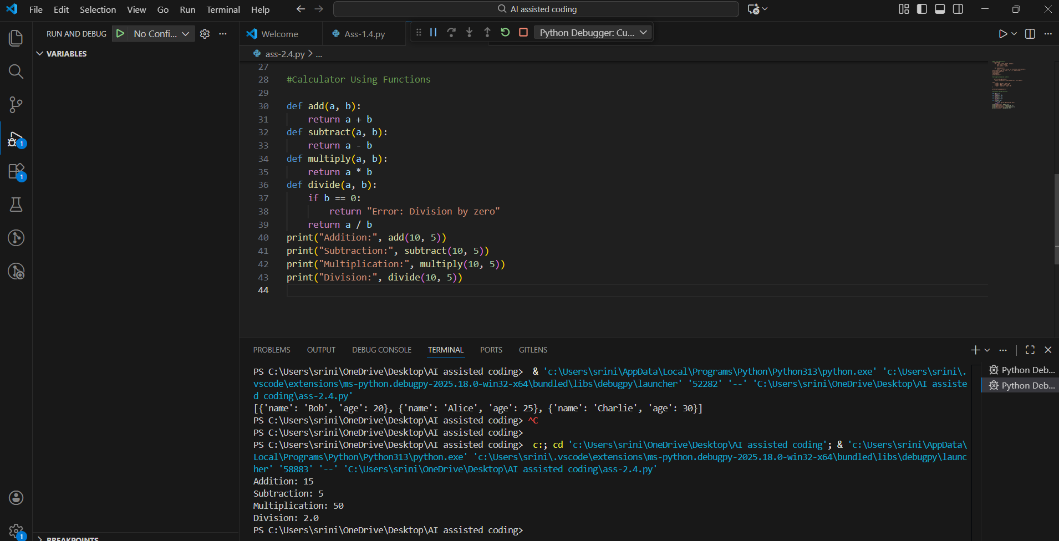
Observation:
- The calculator is implemented using separate functions for each arithmetic operation.
- Each function performs a single, well-defined task, improving clarity.
- The divide() function includes error handling to avoid division by zero.
- This modular design makes the program easy to understand, test, and maintain.
- Functions can be reused in other programs without modification.
- Overall, the calculator follows good programming practices and clean structure.

Task 4: Armstrong Number Optimization
Scenario
An existing solution for checking Armstrong numbers is inefficient and limited.
Prompt Used (Gemini AI)
Generate a Python program to check whether a number is an Armstrong number.

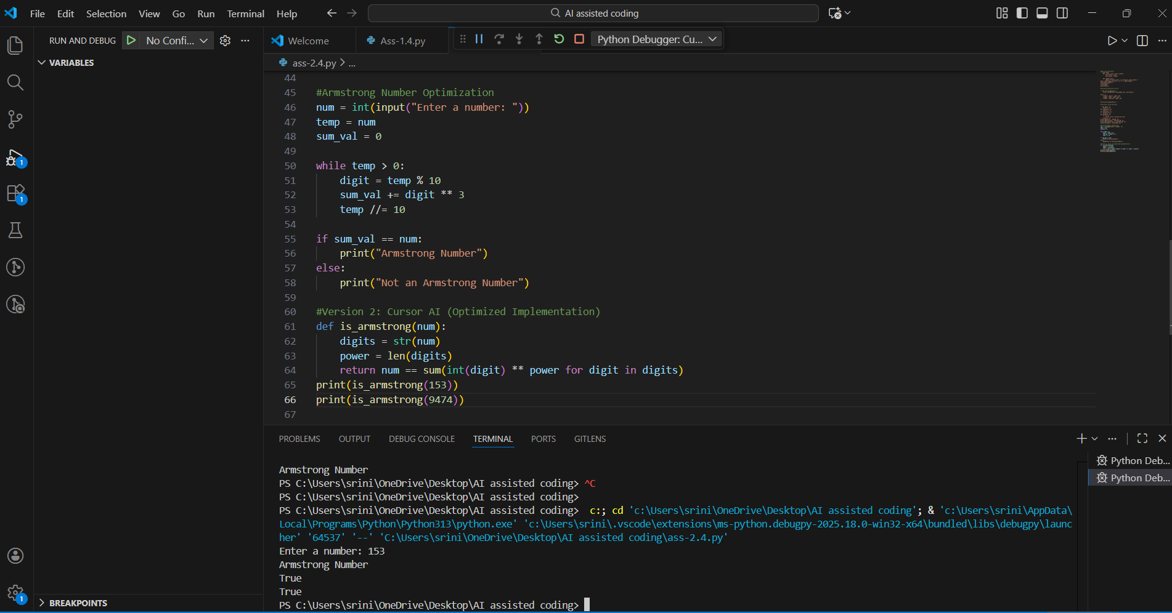
Observation:
1.The optimized version supports Armstrong numbers of any length, not just 3-digit numbers.
2. It replaces manual loops with generator expressions, making the code concise.
3. Readability is improved through meaningful function naming.
4. Temporary variables are reduced, lowering the chance of logical errors.
5. The optimized solution is more scalable and reusable.
6. Code execution is faster and easier to maintain.

